Shabbos Stories For
Parshas behar-bechukosai 5786
Volume 17, Issue 35 22 Iyar/May 9, 2026
Printed L’illuy nishmas Nechama bas R’ Noach, a”h

Inspiring Stories
About the Baba Sali, zt”l

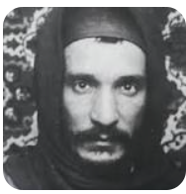
The Baba Sali as a young Tzadik in Morocco

Baba Sali was deeply concerned for the poor in his community. He made sure they had sufficient money for food, clothing, and all their needs before the Yomim Tovim, so they would not feel ashamed before their neighbors. Whenever he bought clothing for himself or a family member, he would purchase an extra item for a poor person as well.
One year, he had to leave home for a month before Pesach and would not be able to personally distribute his usual assistance. He entrusted one of his sons with a large sum of money, urging him not to delay and to ensure the poor received what they needed. The son faithfully distributed the funds before Yom Tov. When Baba Sali returned, he confirmed that food—fish, wine, matzah, and meat—had been purchased, and that the poor conveyed their gratitude.
But when he heard that no clothing had been bought, he immediately hired tailors. Though they said the garments could not be completed before Yom Tov, he insisted they begin. He then called the poor to show them what was being prepared, explaining to his family that even knowing they would receive clothing after Yom Tov would increase their joy during it.

A Great Sensitivity to the
Personal Hardships of Other Jews
In Morocco, Baba Sali guided the Jewish community of Tafilalt with firmness in matters of obligation but with great sensitivity to personal hardship. Once, upon visiting a remote village, he was warmly received by the community leaders and Rabbonim. Before accepting any hospitality, he asked to be taken to the local mikveh.
The community head embarrassedly admitted it had long been abandoned—its water putrid, its structure crumbling, and dangerous to enter. The townspeople traveled elsewhere for a mikveh. Despite their warnings about stench, falling debris, and even scorpions and snakes, Baba Sali insisted. Declaring he would not leave until the mikveh was made kosher, he entered, removed his shoes, lifted his garments, and began bailing out the filthy water himself.

A Miraculous Heavy Rainfall
Ashamed yet inspired, the community elders joined him. When it was emptied, he raised his hands to Heaven and cried, “Hashem, we have done our part; now do Yours.” Immediately, heavy rains fell and refilled the mikveh. The villagers rejoiced at the miracle and felt spiritually uplifted.
Yet Baba Sali expressed concern. According to the Beis Yehuda, he believed the mikveh might still be invalid due to its iron pipes. The villagers resisted emptying the miraculously provided water, but he refused to allow a questionable mikveh to exist. The water was drained again, and wooden pipes replaced the iron ones. When complete, he prayed once more—invoking the author of the Beis Yehuda—and again a deluge came, refilling the mikveh properly. Only then did he return home, leaving behind an inspired and strengthened community.

Reprinted from the Parshas Tazria-Metzorah 5786 email of The Weekly Vort.

“How Can I Not Feel the
Pain of Another Jew”

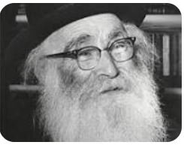
Rav Aryeh Levin, zt”l

Horav Aryeh Levin, zl, was no stranger to adversity and suffering. During his lifetime, he buried children, lived in abject poverty in which the only thing palpable in his house was the hunger. His body was weakened by illness, and his life was marked by quiet suffering. Yet, he never once uttered a word of complaint. He did not merely endure his suffering, he accepted it.
When asked how he was able to sustain so much loss, Rav Aryeh remarked with utter simplicity, “If Hashem gave this to me, then obviously He feels I am able to carry the load.”

Never Feeling Abandoned by Hashem
This was Rav Aryeh’s mission statement of emunah. He saw pain, not as Hashem abandoning him, but rather, as Divine trust and confidence in his ability to succeed. Rav Aryeh also was silent – a silence born of submission, faith and the privilege of serving Hashem.
Rav Aryeh did not just feel his own pain; he was also sensitive to the pain of others. He visited prisoners of the British Mandate who were on death row. He sat and cried with them, treating each one as a precious soul (which everyone was). He talked to them as a loving father addresses his son.
When asked how he could absorb so much suffering, he replied, “If another Jew is in pain, how can I not feel it?” When one comes to terms with his own suffering, he is then able to carry -- and empathize with -- the suffering experienced by others.
Accepting the suffering does not mean one becomes absorbed in himself, lives in a secluded bubble. It means that he remains active helping others. Some people privately endure suffering; others are unable to endure and fall victim to its crushing effect. Others rely on their deep-rooted faith and trust. Thus, Hashem’s decree elevates him. After all, it is His will.

Reprinted from the Parshas Shemini 5786 email of Peninim on the Torah, a publication of the Hebrew Academy of Cleveland as edited and compiled by Rabbi L. Scheinbaum.

The Challenge of Not
Bearing a Grudge
By Yehuda Z. Klitnick

In the 1930’s, Kollel Galizia in Israel helped Yidden that immigrated to Yerushalayim from Galicia, Poland. They would give them money for food and clothes, and also had a Kollel for serious Talmidei Chachamim. There were two Yungerleit, R’ Asher and R’ Menachem, who learned in the Kollel.
R’ Asher didn’t get along with R’ Menachem and constantly looked for ways to make his life miserable. Whether a harsh word or a mischievous act, he would always find a way to attack R’ Menachem.

Rav Menachem Never Answered Back or Retaliated
However, Rav Menachem was a true gentleman, and a scholar, and never answered or retaliated. He simply accepted this decree from Hashem. However, R’ Asher didn’t let up until it started effecting R’ Menachem’s learning and davening.
R’ Menachem was a chosid of Reb Dovid Lelover zt”l, and he decided to seek advice and pour his heart out to the holy tzaddik. The Rebbe listened and thought, and then he said “By not answering back you will achieve great heights spiritually, and you will eventually benefit financially from it.”
The Rebbe gave him a Bracha that he should have the strength to continue to cope. R’ Menachem had Emunah and was a strong believer in the Rebbe and was satisfied that everything will be ok. However, he couldn’t understand how will he gain materialistically from R’ Asher when he is his archenemy!
Soon after, R’ Menachem’s two sons became engaged and he needed money to get them married. The Kollel Galicia had an agreement with a rich donor in Vienna, Austria, who would sponsor a wedding if one had a letter of recommendation from the Kollel confirming that the person in need was a Talmid Chacham.

Anticipating a Rather Short Stay in Vienna
R’ Menachem traveled to Vienna and anticipated he would be only a day or two in Vienna and then return to Eretz Yisrael. R’ Menachem asked where the rich person lived and he set out to visit him. R’ Menachem took along his letter and was confident that he would help. R’ Menachem knocked on the door. When the door opened, the rich Yid was in middle of a business meeting, and his servant told R’ Menachem he can’t see him today.
R’ Menachem began to tell him that he was going back to Eretz Yisrael soon. The servant said “Ok, if you want a small donation you can get one now. However, if you need help for a wedding you will have to come back in a week.”
R’ Menachem had no choice and made an appointment for the following week. R’ Menachem decided to find a hotel and in the meantime went collecting for his wedding. He was very successful. During the 1930's in Vienna, it was illegal for someone to go around collecting for himself, as you could only collect for a reputable organization.

Approached by a Viennese Police Officer
R’ Menachem did not know the laws and had no idea it was illegal. As he was collecting, a police officer approached him and asked who he was collecting for? R’ Menachem answered on the spot I am from Kollel Galicia in Israel and showed him his papers. The policeman didn’t believe him, and said he must come to see the Police Chief. R’ Menachem was very calm and had faith in Hashem and went along.
At the Police station, R’ Menachem was questioned by an officer who asked who he was collecting for? R’ Menachem answered for Kollel Galiza! The officer went to check if the Kollel was a reputable organization, and he found out that it was. He told R’ Menachem I still suspect you were really collecting for yourself! The officer said I will have to find out if you have a good job or if you are a needy person.
R’ Menachem exclaimed: I work for Kollel Galicia and get paid very well and I am not a needy person. The officer asked R’ Menachem for the telephone number
from the Kollel. The officer placed a call to the Kollel in Yerushalayim. When the call came in, the operator said there is a call from Vienna. Someone wants to ask information on Menachem from the Kollel!

The Phone Call is Answered by R’ Menachem’s Nemesis
To R’ Menachem’s Divine Providence R’ Asher answered the call. R' Asher figured who can be calling from Vienna? It must be that the rich Yid calling to ask information on R' Menachem, and when he was asked if Rav Menachem worked in the Kollel, he answered, “Yes.” And when asked if was a needy person or was well to do? He answered “He is well to do and is not at all a needy person.”
The officer thanked him and hung up. Back in Vienna the officer told R' Menachem that everything checked out to be fine and he let him go. R’ Menachem breathed a sigh of relief, and thanked Hashem for His help. R’ Menachem opted to stay in shul and learn and wait for his appointment.
The day came to meet the wealthy Yid and R’ Menachem was received very warmly. After a nice and friendly discussion, the Yid agreed to pay for the both weddings. R' Menachem thanked him, and headed back home a very happy person.
Back in Jerusalem, R' Menachem went to visit his Rebbe and told him the whole story about the police and the telephone to the Kollel!

Sending the Shamesh to Find Out
Who Spoke to the Police Officer
The Rebbe exclaimed: “I wonder who spoke to the officer in Vienna?” The Rebbe sent his Shamesh to find out. The Shamesh found out that it was R' Asher who answered the call. The Rebbe summoned R' Asher to come to him. The Rebbe told him that when he answered the call from Vienna, he had meant to harm R' Menachem. However, with his information, he saved R' Menachem from going to jail. The Rebbe told him the whole story!
This is a sign from Heaven that you should make up with R' Menachem! R' Asher lowered his head in embarrassment and said, “I realize the Rebbe is right”! The Rebbe said, R’ Menachem is in the next room. Are you ready to ask forgiveness? He answered “Of Course,” and he gave his hand to R' Menachem and they forgave each other. Now R' Menachem understood what the Rebbe had said: By not answering back he will not only gain spiritually but also financially and physically.

Reprinted from the Parshas Shemini 5786 email of Pardes Yehuda.

The Unusual Pesach
Halachic Query
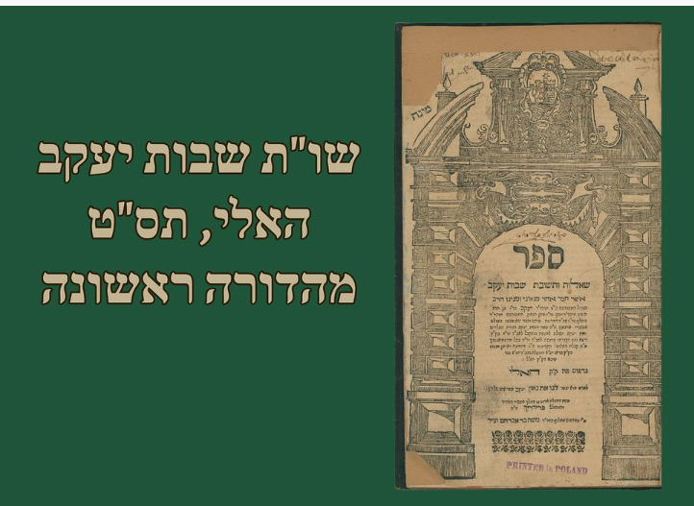
First Edition of the “Shvus Yaakov” published in 1709.

An unusual situation was once presented in the Beis Din of R’ Yaakov Reischer zt”l, the “Shvus Yaakov.” A Jewish man married a non-Jewish woman, k"r. As if this wasn’t bad enough, he came to the rabbi a few days before Pesach with an important halachic query. He explained that although his wife is a non-Jew, he himself is a practicing, religious Jew, and aside from the fact that he is married to a gentile, he is careful to keep the Torah and mitzvos in every other way.
The dayanim looked at him with shock and unmitigated surprise but the man was undeterred. He turned to the sitting judges and presented his case to the esteemed rabbinate: are the chametz products that his gentile wife purchased over Pesach permitted to him immediately after the holiday as they belonged to a non-Jew during Pesach; or perhaps they are forbidden to him because the Talmud states that whatever belongs to a wife belongs to her husband, and therefore, her chametz falls under the category of " - forbidden chametz that was in the possession of a Jew during Yom Tov?
The words dropped like stones. One dayan’s face drained of color. Another shifted uncomfortably. A third stared at the table, stunned. It was not merely a halachic problem - it was a spiritual tragedy. But R’ Yaakov maintained his composure. He conferred with his colleagues for a few minutes. Then he called an attendant and asked for a sefer. He opened the sefer entitled, “Shvus Yaakov” and turned a few pages. He read through a number of paragraphs and then he looked up satisfied.
Turning to the questioner, he spoke with measured clarity. “In halacha,” he said, “the rule that a husband acquires what his wife acquires applies only within a Jewish marriage.” He then quoted the principle exactly as he wrote it in his teshuvah: “This rule, that whatever a woman acquires her husband acquires, applies only to a Jewish woman.” He explained that the halachic mechanism of a husband’s rights over his wife’s property exists only when the marriage itself is halachically recognized. A gentile woman, however, is not considered a wife in Jewish law.
Thus, he continued, again using the language preserved in his written ruling: “But regarding a gentile woman - the husband has no rights whatsoever in her acquisitions.” The man listened intently, absorbing every word. R’ Yaakov concluded reading with the words: - “Therefore, her chametz is like the chametz of any gentile.” The ruling was complete. The chametz was permitted to him after Pesach! The man thanked the Rav with relief and left the Beis Din.
Only after the door closed did the tension in the room break. One of the dayanim turned to R’ Yaakov, his voice trembling. “Rebbe, please teach us. How could you answer him so calmly? A Jew married to a non-Jew - and he asks about chametz?”
R’ Yaakov closed the sefer gently. Looking around at the quizzical looks on every face in the room, he declared in a soft tone, “If this man still cares enough to ask a sh’eilah about chametz,” he said with conviction, “then a spark of Yiddishkeit still burns within him. If we push him away now, we may extinguish it forever.”
The dayanim fell silent. This story was retold in later generations and according to one accepted version, that spark did not go out. The man eventually returned - not with another halachic question, but with a heart seeking teshuva and repentance. The Rav’s calmness, his refusal to shame him, had opened a door. In time, he separated from the gentile woman and returned to Torah.

Reprinted from the Pesach 5786 email of Rabbi Dovid Hoffman’s Torah Tavlin.

The Three Cutting Boards
By Rabbi Moshe Hirschberg

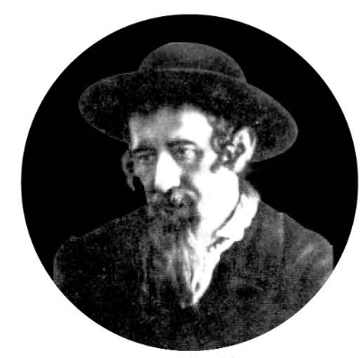
Reb Mordechai Dov of Hornosteipel

When Reb Shlomo of Bobov (1907– 2000) was still a young child, his grandmother — the wife of Reb Ben Tzion Halberstam, the Rav of Ratzport (1874–1941) — once came to visit his home. As they sat together, she began to share a memory from her own youth, a story that had unfolded in her father’s home — the home of Reb Mordechai Dov of Hornosteipel (1839–1903).
“There was once,” she began, “a husband and wife who came to my father seeking help with their shalom bayis. He listened patiently, guided them through their quarrels, and sent them home in peace. But a few months later, they returned again — and again after that.
“Finally, the wife sighed and said, ‘Rebbe, please give me a brachah for everlasting shalom bayis. I don’t want to have to come back every few months.’” The Rebbe smiled. “If that’s what you wish, I’ll give you a way to achieve it. This Friday, go and clean three lokshen breit.”
The woman blinked. “Three lokshen breit?” — referring to the wooden cutting boards used to roll and slice homemade noodles. It was a strange instruction, but she trusted the Rebbe. If this was the segulah for shalom, she would do it.
That Friday, she set out to fulfill his words. Her first stop was a small home filled with noise — ten children running underfoot, chaos swirling around her. She squeezed into the cramped kitchen and began scraping dried dough off the board. The heat, the noise, the tight space — it was exhausting. Still, she told herself that the next home would surely be easier.
But when she reached the second house, peace was even further away. The air was thick with tension; harsh words echoed from one room to the next. The husband and wife barely spoke without snapping. Cleaning that board took every ounce of strength she had — not because of the grime, but because of the heavy spirit that filled the home.
By the time she arrived at the third home, she was weary — but determined to complete her task. To her surprise, it was even worse. The husband shouted so loudly that his words seemed to shake the walls. The wife stood silent, eyes downcast. The woman cleaned in silence, her heart aching. When she finished, she walked out into the cold air and stopped. She stood there a long while, realizing what her Rebbe had truly meant.
This was no segulah. It was a lesson. Reb Mordechai Dov hadn’t sent her to clean cutting boards — he had sent her to polish her perspective. Until that day, she had believed her own home to be uniquely burdened with hardship. But now, after stepping into three other homes — each with its own noise and tension — she saw her life with new eyes.
“My father wanted her,” she said softly, “to see that every household has its challenges. When we imagine others live easier lives, we grow resentful of our own. But when we realize that everyone carries their share of struggle, gratitude replaces frustration — and peace returns.”
She looked at her grandson and smiled. “Sometimes, simchah and shalom doesn’t come from changing our situation — but from changing our sight.”

Reprinted from the Parshas Vayeira 5786 email of Zichru Toras Moshe.

The Powerful Jewish Mother

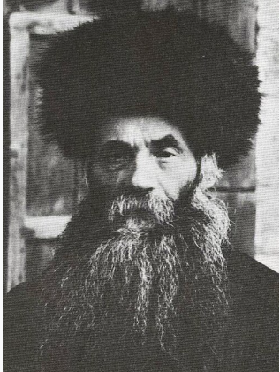
Rav Isser Zalman Meltzer, zt”l

Nachlas Tzvi relates a powerful story that demonstrates the devotion and commitment which a young Yeshivah student demonstrated, as well as the reward he achieved for his sacrifice in order to learn Torah. During World War I, Rav Isser Zalman Meltzer, zt”l, decided to close his Yeshivah in Kletzk, stating that he could not take responsibility for the safety of his students. He therefore sent everyone home for their own benefit.
Upon returning home, one young student was asked by his mother, “Why have you come home?” He said, “The Rosh Yeshivah sent everyone home for their own safety.” The mother began to raise her voice, “Do you think that you are more-safe here than in the Yeshivah? I want you to return to the Yeshivah to learn Torah!”
The boy said, “But Mother, I have no money to purchase a ticket for the train.”
She responded, “Then you will walk. Return immediately to the Yeshivah. The Torah will protect you!” The young student listened to his mother, and he began to walk the few hundred kilometers back to the Yeshivah. After almost a week of walking, the young student appeared before Rav Isser Zalman and said, “Rebbe, I have come to learn Torah!”
Rav Isser Zalman said, “Why are you here? I sent you home for your safety!”
The student related his conversation with his mother and how he walked back to the Yeshivah. Hearing this, Rav Isser Zalman was overcome with emotion. He was impressed with a Jewish mother’s self-sacrifice to risk her child’s life for the sake of Torah. To have such amazing faith in Hashem was incredible! To see this devotion transmitted to her son, who was willing to walk hundreds of kilometers to learn Torah, was overwhelming.

Rav Elazar Menachem Mann Shach

Rav Isser Zalmen said to the student, “I would like to buy your shoes from you. I will treasure the shoes that were worn by a young Yeshivah student who displayed such remarkable devotion for Torah study!” Hashem repaid this student for his unparalleled devotion to Torah, as he eventually became the Gadol Ha’dor, the Torah leader of the generation— Rav Elazar Menachem Mann Shach!

Reprinted from the Parshas Tazria-Metzora 5786 email of Rabbi Yehuda Winzelberg’s Torah U’Tefillah
Don’t Tell Him
By Rabbi Yussie Zakutinsky

We are familiar with countless stories about the Baal Shem Tov that illuminate his deep understanding of the neshama. But there is one remarkable account that he himself related, not about his own greatness, but about another.
He once described a simple Jew, an unassuming individual, who performed a single mitzvah that generated such profound nachas, such Divine pleasure, that it reverberated throughout all the worlds. The joy, so to speak, experienced by the Ribbono Shel Olam was so immense that it shook the heavens, related the Baal Shem Tov.
The heavenly hosts, astonished, sought to understand the source of this extraordinary spiritual awakening. They traced it back to this simple Jew, but what exactly had he done? None could say.
At that point, Eliyahu HaNavi offered to descend and uncover the mystery. Disguised, he came to the man’s door and revealed himself. “You should know,” he said, “that the mitzvah you performed yesterday has shaken Shamayim. Its light continues to radiate, and all the malachim are basking in its glow. But no one knows what you did. Please, tell me.”
The man refused. Eliyahu persisted. “I will grant you blessings—whatever you wish. Just reveal the mitzvah.” But the Jew stood firm. “The mitzvah I performed,” he said, “was between me and the Ribbono Shel Olam. That is where it remains. It is not for others to know.”
The Baal Shem Tov concluded: That Jew was myself—in a previous life.
This story captures a profound truth about the neshama. Every mitzvah we perform builds and strengthens our relationship with Hashem. Yet beyond the visible and communal expressions of avodas Hashem lies a deeper yearning: the desire for an intimate and private connection with the Divine.
There is a powerful perspective embedded in this teaching.
A person may engage daily in many mitzvot; tefillah with a minyan, donning tefillin. These are essential, beautiful, and often public expressions of our avodas Hashem. But there is unique power in a different kind of mitzvah: one that is hidden, known only to you and Hashem.
From time to time—perhaps once a day or even once a week—choose to perform a mitzvah in complete secrecy. Consciously dedicate it as something shared exclusively between you and the Ribbono Shel Olam. Resolve not to speak of it, not to publicize it, not to seek recognition for it.
Over time, such acts cultivate a deeper, more penimiyus-like bond; a relationship not built on visibility, but on authenticity and intimacy.
In a world that often celebrates what is seen, there is something profoundly transformative about what remains hidden. Keep secrets with Hashem: mitzvos and good deeds done purely for Him.
Who knows, perhaps one day there will be a knock at your door. And when that happens, just remember: don’t tell him what you did.

Reprinted from the Parashat Shemini 5786 email of the Torahanytime Newsletter as compiled and edited by Elan Perchik.

Saving One’s Wife a
Few Second of Worry
By Yoni Schwartz

Some time ago, when Yeshivah Torah Voda’as was building its new location in Williamsburg, they decided that they wanted to start off the yeshiva on the right foot. For the first seven days, they were going to have bochurim learn in the Beis Midrash 24/7 to maintain an atmosphere of holiness. Everything went well until Friday night came. Since all the boys went to eat at people’s homes, and nobody wanted to wait a couple of hours to start their meal, none of the bochurim were able to stay and learn.
Rav Shlomo Heiman, ZT”L, the Rosh Yeshiva at the time, knowing that his wife would have no issue waiting a little to start their meal, offered to stay. He sent one of the bochurim to tell his wife that he was going to be late. Immediately afterward, he sent another boy to call him back. “I’ll tell her myself,” he said.
The boys were a bit shocked. “Does the Rav not trust us?” they asked.
Rav Heiman explained: “When my wife opens the door, the first thing she’ll see is bochurim, and she’ll be worried that something happened to me. Then the bochurim will explain the situation, and she’ll realize that everything is okay. However, for those couple of seconds, she’s going to be very worried, and I don’t want her to go through that.”
The bochurim were amazed by the Rav’s thoughtfulness and consideration for others.

Reprinted from the Parshas Tazria-Metzora 5786 email of Torah Sweets.

